**The Shield:**

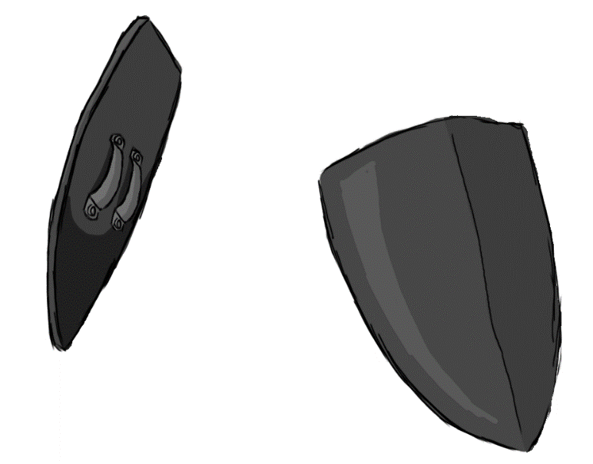

Figure 1 - Weapon: Shield

**Brief Synopsis**

The shield is a defence-based weapon used by the player character. The main usage of this weapon is to keep the player from taking damage, as well as dealing large amounts of knockback with its attacks. The shield’s attacks will not deal any direct damage to enemies and act solely as a method for moving enemies in the player’s path, potentially knocking enemies into hazards. In addition to this, while equipped the shield will apply a minus 20% movement multiplier, slowing the player down.

**Special Ability**

**Shield Slide:**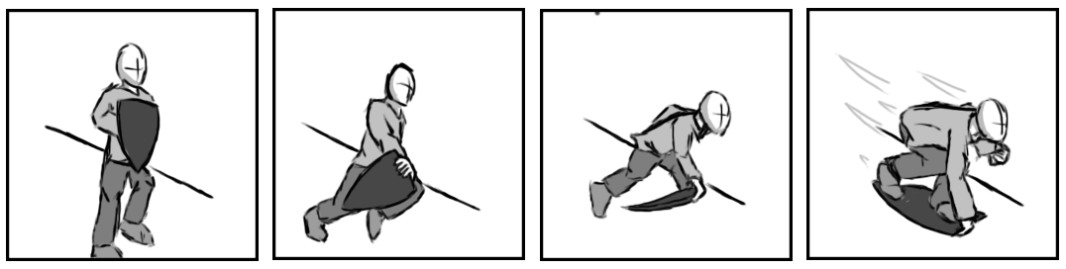

Figure 2 - Animation Storyboard: Shield Slide

**Special:** When used, the player leaps into the air and throws their shield beneath them. If used on a flat plane the animation will cancel as the player hits the floor, leaving them walking or idle. If on a slope or rail, however, the player will begin to slide downwards, accelerating gradually with a much higher max velocity then running.

**Combat Abilities**

**Block:**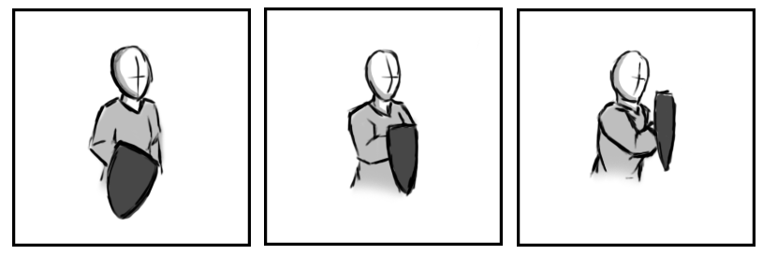

Figure 3 - Animation Storyboard: Block

**While grounded and stationary:** The player holds the shield in front of the player and blocks any attacks coming from with a 180-degree arc in front of the player.

**Charge:  
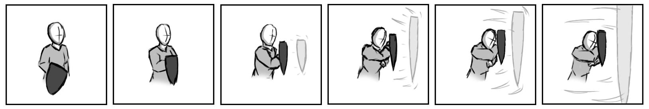**

Figure 4 - Animation Storyboard: Charge

**While grounded and in motion**: The player holds the shield to their front, and charges forward. This will block any attacks coming from with a 180-degree arc in front of the player, while also pushing any enemies that the player collides with backwards and to the side.

**Shockwave:**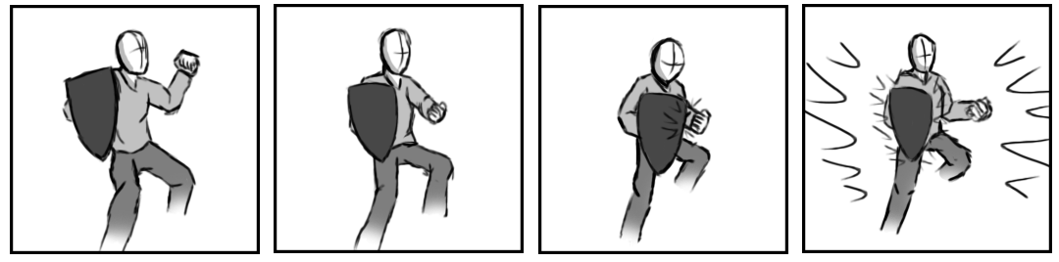

Figure 5 - Animation Storyboard: Shockwave

**While aerial:** This attack has the player hit their shield with their other hand, causing it to vibrate, releasing a shockwave around them. This will push back any enemies within close range.